Objectives:

To practice planning, defining, calling functions, and using Python sequence, decision, and repetition statements.

Description:

For this project, you will be writing several functions that complete the creation of a food service Point of Sale program. The main function is provided in the Project5C.py file and you must create the rest of the program without modifying the main function. You’ll need to study this file to determine how to add your pieces to the code.

Assignment:

1. Build your program using this hierarchical chart:

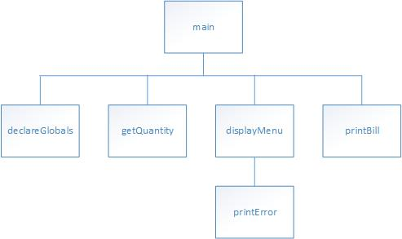

1. Build your menu as such:

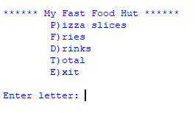

1. The declareGlobals function must declare and/or initialize the constant variables for the item prices of pizza, 5.95, fries, 3.95 and drinks, 2.75. Also the tax should be set at 8.5%. Those are the only global variables you are allowed to have for the entire program.

HINT: Global variables can be declared within a function if you precede the statements with the keyword global followed by the variable names separated by commas (,). Then make the declarations.

1. Format and round all values to 2 decimal places.
2. Name your program POSystem.py
3. Document your code, including the function comments.
4. displayMenu() should display the menu and return the user selected option. It needs to “valid” the user input and ONLY return valid options. It should NEVER return an unavailable option. This will insure that main() never fails. If a user enters an invalid option, it should call printError() (as seen in the sample) and pass into printError an appropriate error message for printing to the screen.
5. The getQuantity() function receives one argument representing the food item text to be printed out for pizza slices, drinks and/or fries after the text “How many …“. See the sample run.
6. The printBill() function receives three (3) arguments representing the quantities of pizza, fries and drinks. Its job is to calculate the tax, total as well as display the itemized bill. See sample output below and item 10 for formatting.
7. The printError() function receives one argument. This string argument is an appropriate error message for when someone enters an invalid selection from the menu. No matter what the argument wording, the output must begin with “Error: …” followed by the message pass by way of the argument. Sample run showing the effect of the printError() function.

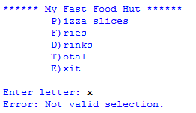

1. Format the bill output per the sample run below. Column widths are up to you, but you must use the format command and proper alignment within those columns, per the sample.

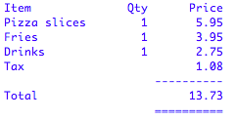

1. Sample run:

